Costpoint Training Guide:
Employee Training Manual
Electronic Timekeeping

Table of Contents:
Table of Contents: 2
Welcome: 3
Activating Your Account: 4
Password Requirements: 5
Accessing the Portal: 6
Becoming Familiar with the Timesheet Screen: 9
User Navigation: 10
Global Toolbar in T&E: 11
Entering a Timesheet: 12
Timesheet Header: 13
Timesheet Lines: 14
Charge Lookup: 14
Entering Hours: 15
Saving your Timesheet: 16
Signing your Timesheet: 16
Adding Favorites to Timesheet: 17
Revision Explanations: 18
Correcting Timesheets: 19
Making Changes Prior to Signing the Timesheet: 19
Making Changes to a Prior Timesheet That Has Been Processed: 19
Resetting a Password and Unlocking Your Account: 20
Completion: 21

Welcome:

All Advanced Sciences & Technologies employees will utilize Deltek Time & Expense [T&E] to record hours worked. The following document is our Time Collection [TC] training for employees.

Welcome to Deltek Time & Expense – Time Collection training!

We want you to be able to complete your timesheet as easily as possible. Accurate timesheets are critical because they affect everything we do, from tracking progress and managing contracts, to invoicing, cash flow, and staying in business. Timesheet data must be accurate as it flows into all modules of the corporate-wide system, so any mistakes in your Timesheet can be amplified.

Activating Your Account:

Upon receiving the activation e-mails from Deltek, follow the instructions included in the emails to access the activation website and activate your account.
- The e-mail will include the link to Deltek’s account activation website
- Upon accessing the link, enter the username and temporary password from your emails into the upper left part of the page and follow the instructions to create your security questions and permanent password

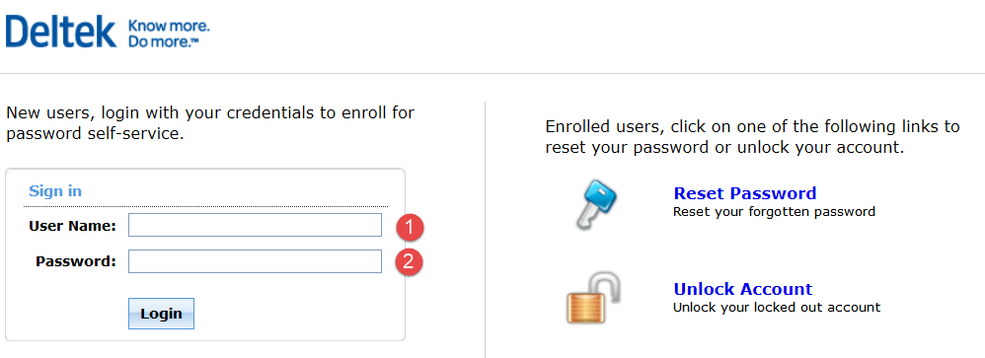
Note1: If you receive a page error message, please try completing this step using an alternate browser, such as Chrome or Firefox. The site has some compatibility issues with certain versions of Internet Explorer, and Safari, so depending on which version of the software you are using, you may come across this issue.
Note2: Passwords are case sensitive. Upon entering an incorrect password 3 times, your account will automatically lock. You will need to contact administration to unlock your account. Please e-mail your accounting department and request that your account be unlocked.
Upon successful activation, please proceed to your web portal by following the steps below. Please do not attempt to access the portal or the timesheet system prior to successfully activating your account.

Password Requirements:

- Passwords may not contain the user’s account name or two consecutive characters that spell parts of the user’s full name
- Passwords must be at least eight characters in length
- The last 10 passwords cannot be re-used
- Passwords must contain characters from three of the following four categories:
  - English uppercase characters (A through Z)
  - English lowercase characters (a through z)
  - Base 10 digits (0 through 9)
  - Non-alphabetic characters (for example, !, $, #, %)
- Passwords are active for 90 days. Two weeks prior to expiration, users will receive an auto email prompting a password change

Accessing the Portal:

First double click on the Internet Explorer Browser Icon or another web browser.



In the address line, enter the following path:
https://www.costpointfoundations.com/advscitech/portal.html
Please add this as a bookmark on your browser.

Logging into Deltek Expense:

Click on “Enter your Timesheet or Expense Report”.
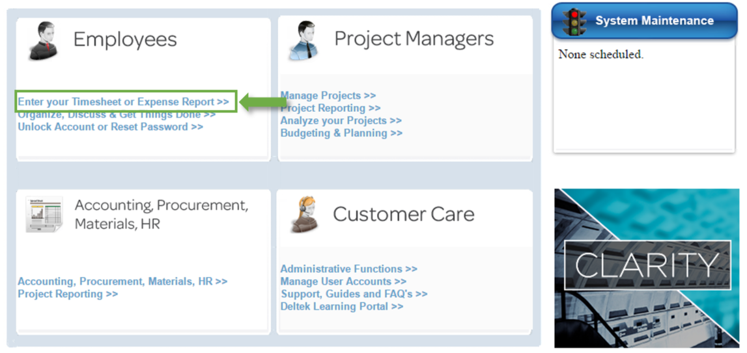

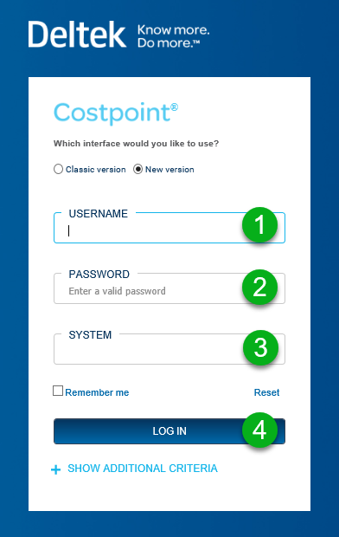

Enter your credentials, system and click “Log In”. Note that your username and system are NOT case-sensitive. Your password IS case-sensitive.
Username: 48884.FirstName.LastName
Password: Password created by user
System: ADVSCITECH

Becoming Familiar with the Timesheet Screen:

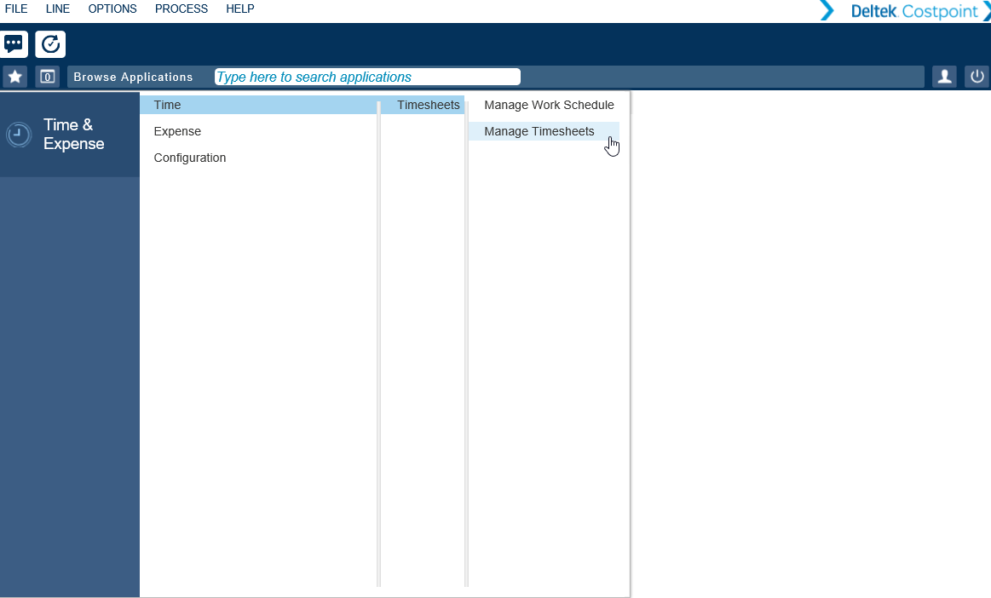

- Depending on your job functionality, you may see additional modules
- All users will see the Time & Expense module
- To Navigate to your Timesheet, select “Time”, “Timesheets”, and “Manage Timesheets”

User Navigation:

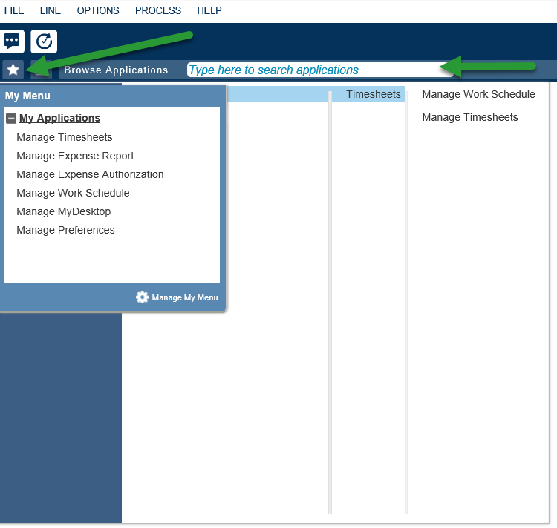

- Users can add applications to a menu list, My Menu, for quicker access
- Users can also use the browse bar, Browse Applications, to quickly access applications in the system.

Global Toolbar in T&E:

The below explains the options available on your Global Toolbar. Items that are enabled depend on the application and process.

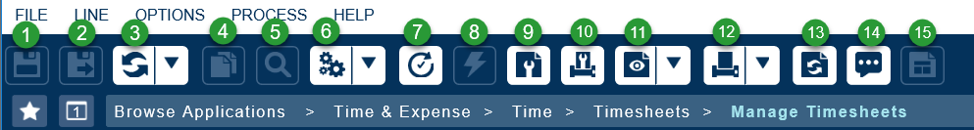

- Save
- Save & Continue
- Refresh
- Clone Record
- Look-up
- Default Action
- View Action and Report Status
- Execute
- Page Setup
- Print Options
- Print Preview
- Print Menu
- Reset Default Positioning and View
- Show Messages and Errors
- Apply Two Column Layout

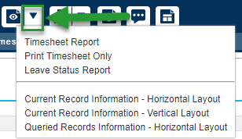
Split Buttons: Several of the toolbar actions have split buttons available. They are indicated by the down arrow next to a given toolbar icon. Click on the down arrow to receive additional options for this action.

Entering a Timesheet:

The system will open to the current timesheet, as shown below. 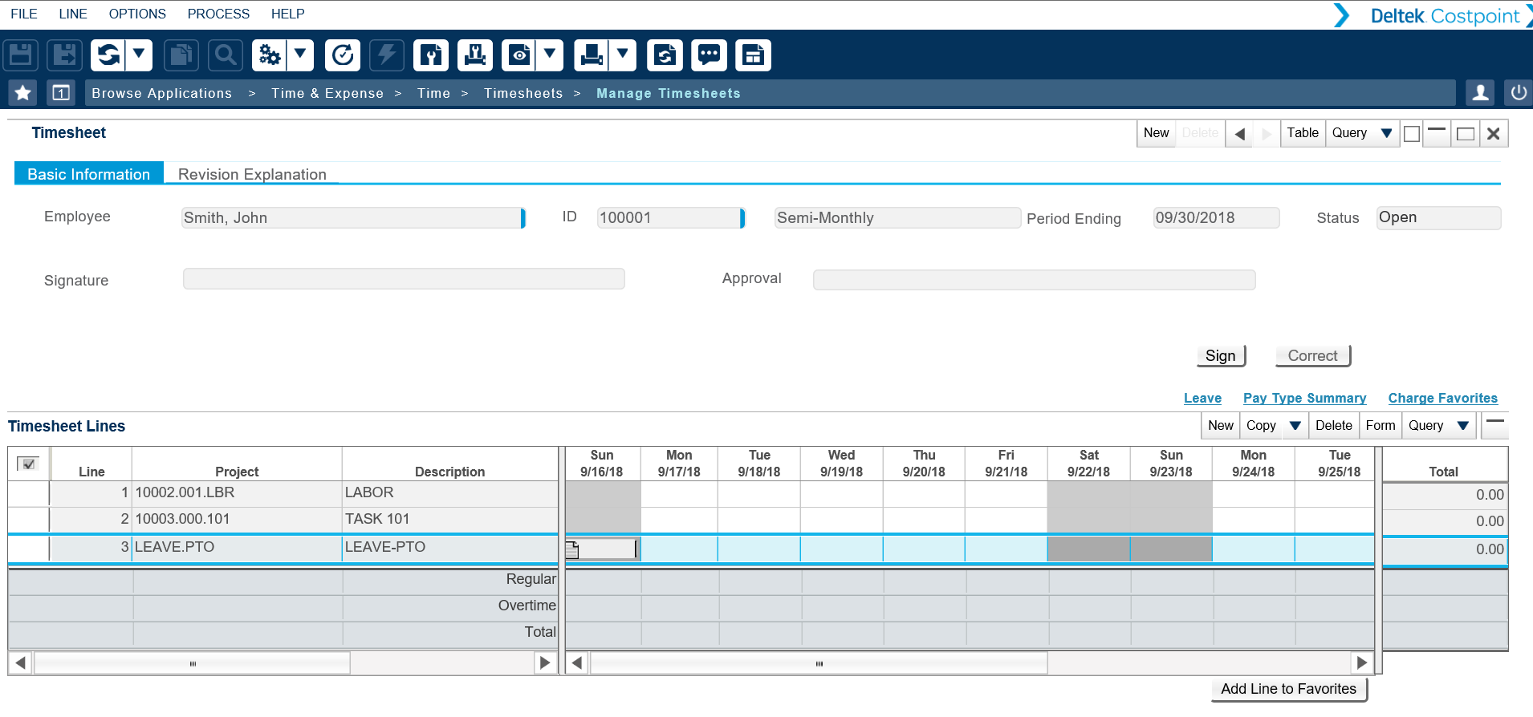

Next, we will break the timesheet header into sections to better explain each area.

Timesheet Header:
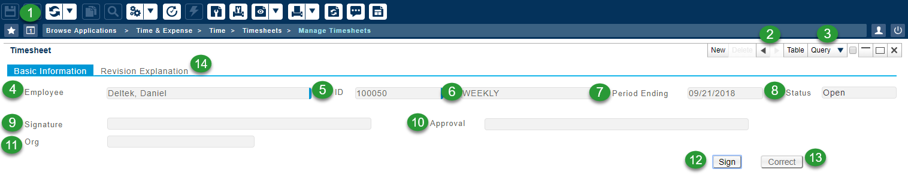

- Save: Select the Save option to save the changes made to your timesheet
- Arrows: Use the arrows to move between timesheet weeks
- Query: Select the Query option to open a specific timesheet
- Employee: Non-editable field displays your last name, first name, and middle initial (if supplied) as submitted to your human resources department
- ID: Non-editable field displays your employee ID number
- Class: Non-editable field dictates the business rules that will be in effect during timesheet entry for the class that is assigned to you
- Period Ending: This non-editable field displays the period ending date, based on the company's timesheet schedules and the schedule that is assigned to you
- Status: Non-editable field displays the status of the current timesheet
  - MISSING: Timesheet has not been started
  - OPEN: Timesheet is in progress and has not been signed by the employee or approved by the employees’ manager
  - SIGNED: Employee has completed the signing process
  - APPROVED: Employees’ manager has completed approval process
  - PROCESSED: Timesheet has been electronically sent to the company’s accounting system
  - REJECTED: Timesheet has been rejected during processing. This status usually means that the data on the timesheet is not correct as it stands
- Signature: Employees’ electronic signature upon completion of timesheet
- Approval: Manager electronic signature of approval of employee timesheet
- Org: This non-editable field displays the Org ID in which the employee is associated with
- Sign: This button is used to sign a timesheet; a pop-up message will confirm the action
- Correct/Request Correction: This button is used to correct a timesheet after it has been approved by the employee’s supervisor and is within a closed or processed timesheet period. In the event the timesheet period is no longer open, the button will reflect “Request Correction”; once the request for correction has been approved and period is open/timesheet is available, the “Correct” button will be available.
- Revision Explanation: The timesheet revision explanation(s), if applicable, will display here. For each revision, a number will be assigned to it, with a "1" for a new timesheet. The revision number increases automatically by one every time you save auditable changes.
Timesheet Lines:

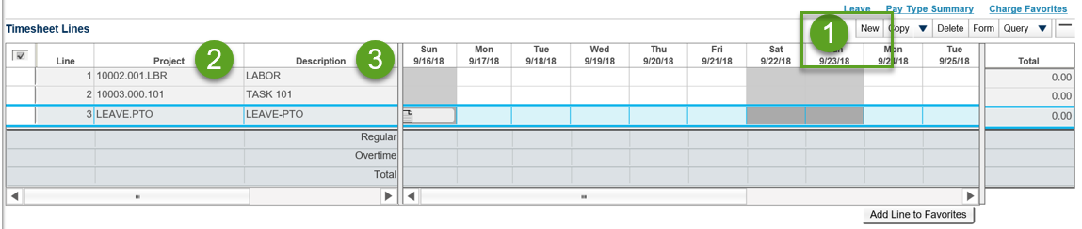
- New: Select the New button to ADD a line to your timesheet
- Project: Manually enter or look up the charge number to be used for the timesheet period
  - To look up the charge number, click on the magnifying glass under the project column and a new dialog box will open; this is the Charge Lookup
- Description: Defaults based on the Charge Number that is entered
Other items that may display on your timesheet:
- PLC (not shown above): This is your project labor category (PLC)
- Pay Type (not shown above): This will default to “R”; if you work overtime you may be required to change this value
Charge Lookup:
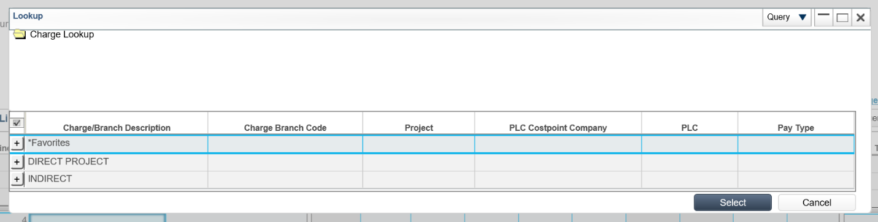
By clicking on an individual charge, the next level, called the “Charge Branch,” will display only those tasks the employee has been assigned to charge by the contract workforce. All other tasks will not be visible.
In the charge lookup window, you have the option to drill down each category by clicking on the “+” next to each line until you find the correct indirect or direct charge code to add to your timesheet.
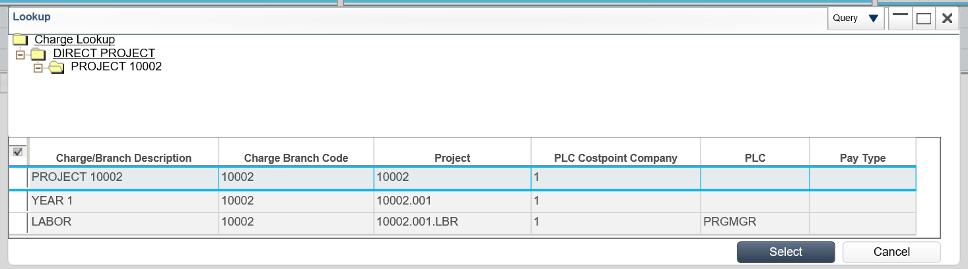
Once the appropriate charge line has been selected, choose the “Ok” button.

Entering Hours:

Hours are entered by day and by charge number. Please note the following:
- Hours can only be entered to the hundredth digit (i.e., 7.51)
- The thick line in the middle of the page is called a splitter bar and splits the timesheet into two sections. This bar may be moved either to the left or the right to show more of either screen
- Future hours can be entered for Holiday and Vacation ONLY
Comments: Comments may be entered on either a daily or weekly basis by clicking on the d notepad icon, shown below, in either the daily or line cell. Only appropriate comments should be entered into the comment box. This is to ensure that inappropriate comments will not carry through to invoices or billing documents that might eventually make their way to a client.
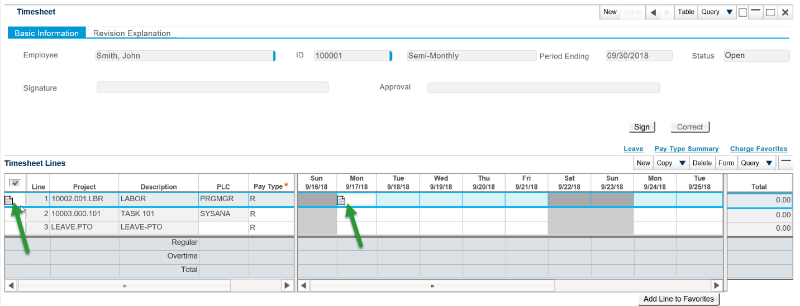

Note, if you do not have any lines listed on your timesheet, please select New, as shown below, and then select the magnifying glass from the Project field to access the Charge Lookup box.
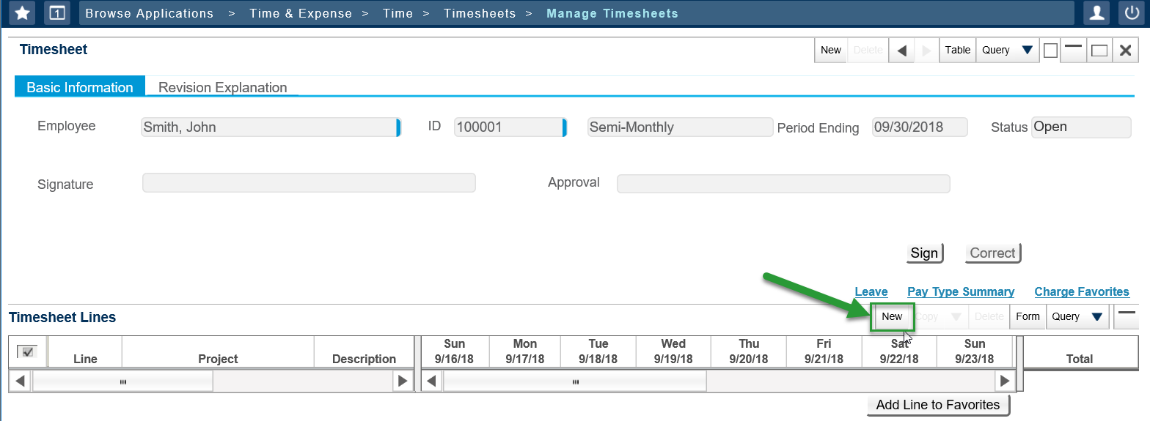
Saving your Timesheet:

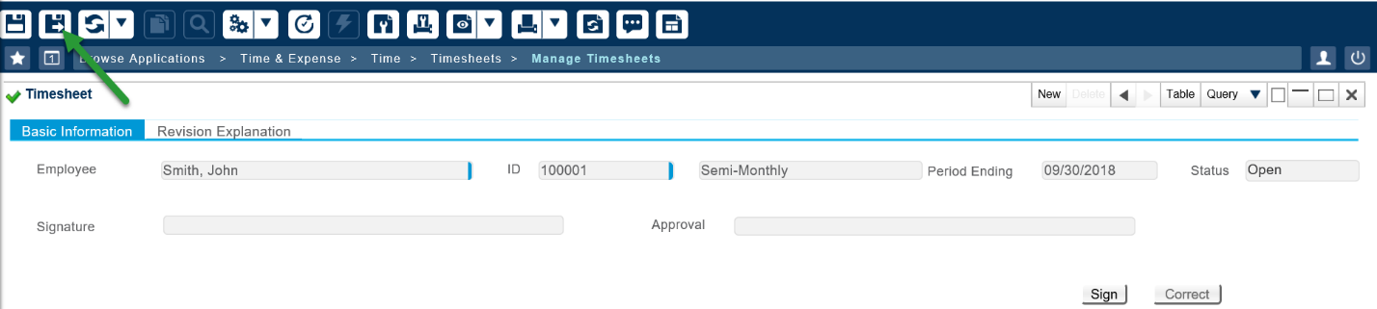
- After you have entered your time for each day, you will need to save your timesheet
- Click on ‘Save’ in the upper left corner of the timesheet
Signing your Timesheet:

After the timesheet has been completed, it needs to be signed before it can be approved and processed. In the Timesheet Header, there is a box labeled “Sign”; click this box to sign your timesheet.

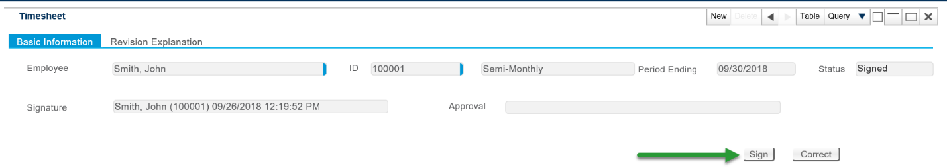

The following dialog box will appear:
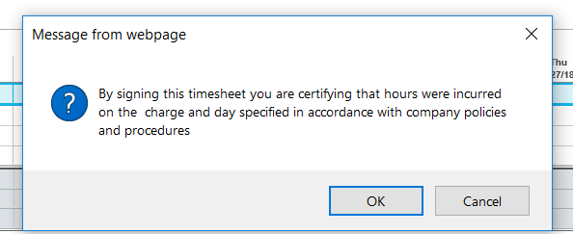
After hitting “OK” your timesheet is electronically signed and the status of the timesheet will change to “SIGNED.”

Adding Favorites to Timesheet:

You can add charge codes to your Favorites by highlighting the box to the left of the timesheet line and clicking the “Add Line to Favorites” button as shown below.
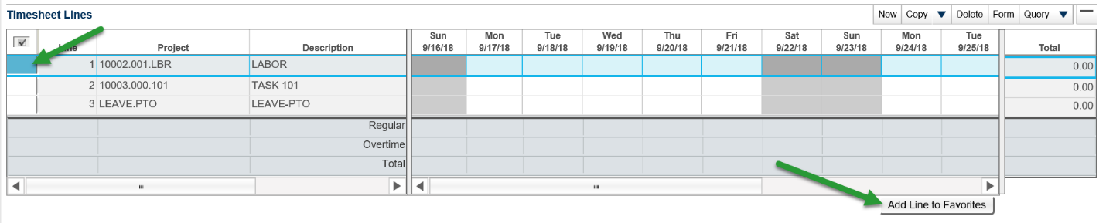

If you would like the items in your Favorites list to automatically default when you first open a new timesheet, please do the following:
- Select Charge Favorites link located at the top of the timesheet lines
- Select the Load checkbox for the rows that you want automatically loaded
- Select Save and Continue once completed
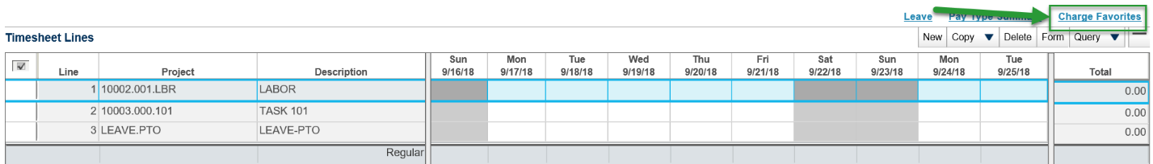
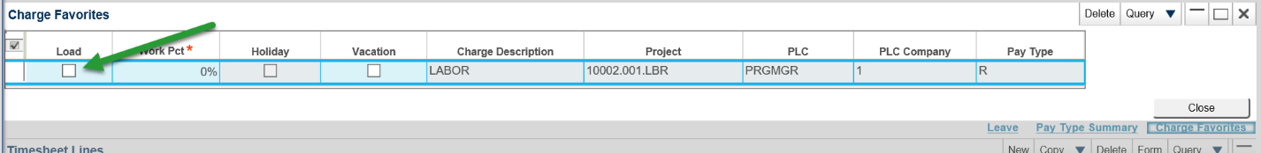
NOTE: If you believe you are missing a charge code that should be available to you, or if you see a direct charge code that should not be available to you, please contact your supervisor.
Revision Explanations:

Any time you change a saved field in a timesheet or any field after it has been signed, you will be required to insert a revision explanation prior to being able to save the timesheet.
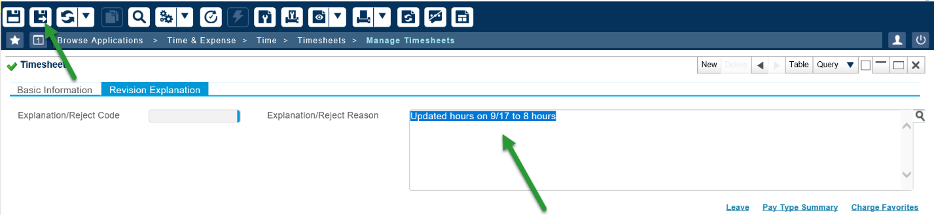
Note, only appropriate comments should be entered into the comment box. This is to ensure that no inappropriate comments will carry through to invoices or billing documents that might eventually make their way to a customer.
Revision explanations allow managers and auditors the ability to review the reason for the timesheet change and can be viewed in the Audit Application.
Revisions can be accessed by the employee or the manager by clicking on the Revision Audit link in the header menu. When accessed a screen appears and shows all revisions for that timesheet.

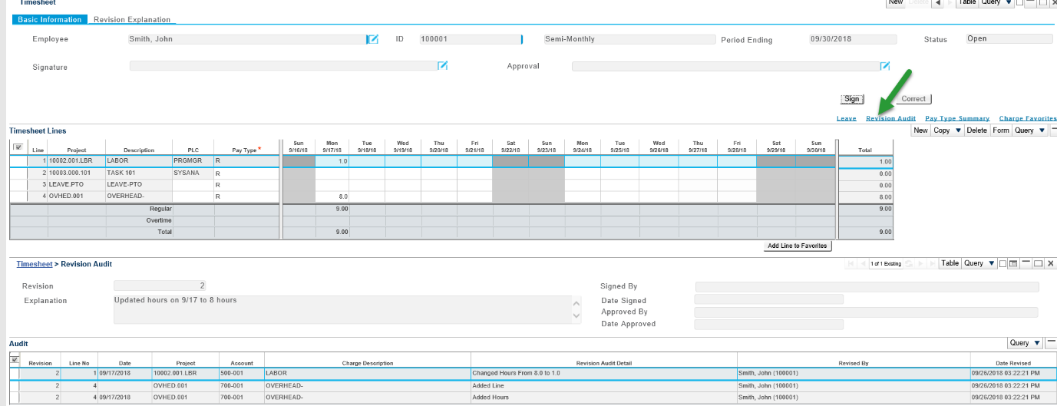
Correcting Timesheets:

Making Changes Prior to Signing the Timesheet:

- Change values within timesheet, such as hours/Project/PLC/Pay Type
- A revision explanation will need to be entered

Making Changes to a Prior Timesheet That Has Been Processed:

If the Correct button is available:
- Click on Correct button
- Make the appropriate changes to timesheet
- Employee will need to sign timesheet
- Manager will then need to re-approve timesheet
If the Request for Correct button is available:
- Click on Request to Correct button
- Administrator will either approve or reject the request in the Timesheet Correction Status application
- Notifications will be sent via email to inform Employee of status
- If approved, click on Correct button
- Make the appropriate changes to timesheet
- Employee will need to sign timesheet
- Manager will then need to re-approve timesheet
*All adjustments that are processed through Electronic Time Collection are required to follow these procedures.

Resetting a Password and Unlocking Your Account:

If you need to reset your password or unlock your account, please click on the “Unlock Account or Reset Password” link located in the web portal. This will take you to Deltek’s account activation website.
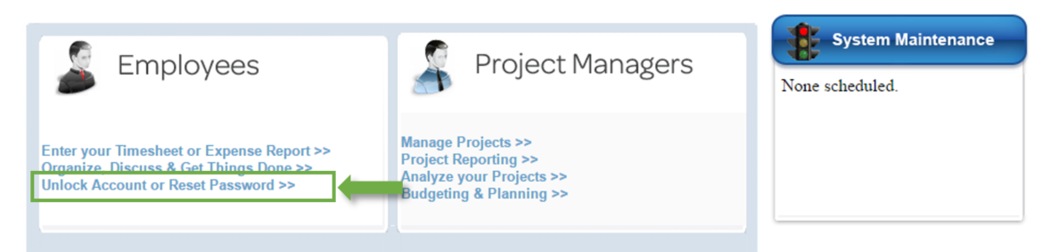

- Once on the account activation page, select the appropriate option from the right-hand side under Account Self-Service and follow the instructions
- Resetting your password also unlocks your account
- Reminder: your password needs to be reset every 90 days. You will receive an e-mail reminder from Deltek prompting you to do so

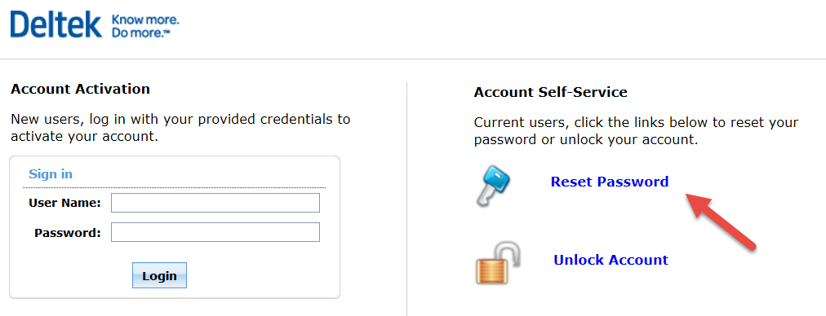

Completion:

Congratulations! You are now an "expert" on basic Time Collection entry, correction, and saving. These are the skills you will need to complete your Timesheet in Time Collection each day.

Please complete and sign this training completion certificate. Then submit the certificate to Human Resources to be included in your personnel file.

Certificate of Completion

Deltek Timekeeping Training

TRAINEE NAME: _________________________________________________________

DATE OF COMPLETION: _________________________________________________

TRAINEE SIGNATURE: ________________________________________DATE: _____________________

